SIMATS ENGINEERING (SAVEETHA SCHOOL OF ENGINEERING)
Department of Artificial Intelligence and Data Science
ASSESSMENT TOOL 1 – Experiments

Course Code: | DSA0307 | Course Title: | Natural Language Processing
CO Assessed: | CO3 – Precision | Assessment: | Assessment Tool 1 – Experiments
Weightage: | 50% of CIA
CO5 Statement: | Apply N-gram models, smoothing techniques, part-of-speech tagging systems and to evaluate effective syntactic analysis. (BL-3)
Student Name: | S.Sri Sai Prasanna Durga | Reg. No.: | 192424241
Section / Batch: | 2024 | Date:

Code of Conduct
I ____S.Sri Sai Prasanna Durga (192424241)_ (Name / Reg No) certify that this submission is my original work and that I have adhered to the guidelines specified for this assessment. I understand that any violation of academic integrity rules will result in disciplinary action.
Signature of the Student: ______S.Sai Prasanna___________________

Instructions
- Perform all experiments using Google Colab.
- Create a separate notebook (.ipynb) for the assessment.
- Ensure all code is executable without errors.
- Include appropriate comments explaining the logic used.
- Complete all three experiments in a single Google Colab notebook.
- Execute all cells and display the outputs for the given test cases.
- Save the notebook with the naming convention: RegNo_Name_CO3-AT1.ipynb
- Upload the notebook to your GitHub repository.
- Ensure the repository is public or accessible to the instructor.
- Submit the following:
- GitHub Repository Link in GCR
- Google Colab Share Link in GCR
- Screenshots of uploaded coding and output files as printout.
- Duration: 30 minutes.

Section / Topic | Focus |  | Experiment Questions
Context-Free Grammars for English Syntax, Context-Free Rules and Trees, Sentence-Level Constructions, Parsing, Top-Down Parsing, Earley Parsing |  | Design a Python program to validate sentences using CFG production rules and construct parse tree representations for valid sentences. | Q1
Agreement, Feature Structures, Sub Categorization |  | Design a Python program to verify subject–verb agreement and validate grammatical constraints using feature structures and subcategorization rules. | Q2
Probabilistic Context-Free Grammars (PCFGs) |  | Design a Python program to parse sentences and compute sentence probabilities using probabilistic grammar production rules. | Q3

Annexure A – Experiments

Experiment 1: Context-Free Grammar Rule Validation and Parse Tree Construction

Experiment Description
Design a Python program to validate whether a sentence follows the given Context-Free Grammar (CFG) rules and generate its parse tree representation.
Grammar:
S → NP VP
NP → Det N
VP → V NP
Det → the | a
N → student | teacher | book
V → reads | likes

Task
- Accept a sentence as input.
- Verify whether it conforms to the CFG.
- Construct and return the parse tree.
- Return "Invalid Sentence" if parsing fails.

Function Prototype
def parse_cfg(sentence):
pass

Test Cases
Input | Expected Output
the student reads a book | Valid Parse Tree
a teacher likes the book | Valid Parse Tree
student reads book | Invalid Sentence
the book likes a teacher | Valid Parse Tree
reads the student book | Invalid Sentence

Experiment 2: Agreement and Feature Structure Checking

Experiment Description
Design a Python program that verifies subject–verb agreement using feature structures containing Number and Person attributes.

Feature Rules
he → singular, third person
she → singular, third person
it → singular, third person
they → plural
runs → singular verb
writes → singular verb
run → plural verb
write → plural verb

Task
- Accept Subject and Verb.
- Compare feature structures.
- Return True if agreement holds.
- Return False otherwise.

Function Prototype
def check_agreement(subject, verb):
pass

Test Cases
Subject | Verb | Expected
he | runs | True
he | run | False
they | run | True
they | writes | False
she | writes | True

Experiment 3: Probabilistic Context-Free Grammar (PCFG) Parsing

Experiment Description
Implement a Python program to compute the probability of a sentence using the given PCFG.

Grammar
S → NP VP [1.0]
NP → John [0.6]
NP → Mary [0.4]
VP → runs [0.5]
VP → walks [0.5]

Probability Formula
P(Sentence)
=
P(S→NP VP)
× P(NP)
× P(VP)

Task
- Accept a two-word sentence.
- Parse using the PCFG.
- Compute sentence probability.
- Return 0 if sentence cannot be generated.

Function Prototype
def sentence_probability(sentence):
pass

Test Cases
Input Sentence | Expected Probability
John runs | 0.30
John walks | 0.30
Mary runs | 0.20
Mary walks | 0.20
Peter runs | 0.00

Exp- 1: Context-Free Grammar (CFG) Rule Validation and Parse Tree Construction
1.Understanding of Concepts:
Aim: To design a Python program that validates whether an input sentence follows the given Context-Free Grammar (CFG) production rules and constructs its parse tree representation.
Objective:
- To understand the concept of Context-Free Grammar (CFG).
- To validate English sentences using CFG production rules.
- To generate parse tree representations for valid sentences.
- To identify invalid sentences that do not satisfy the grammar.
Theory:
A Context-Free Grammar (CFG) is a formal grammar used in Natural Language Processing (NLP) to describe the syntactic structure of sentences. It consists of production rules that define how words combine to form valid sentences.
A CFG has four components:
- Non-Terminals – Symbols that can be expanded (S, NP, VP).
- Terminals – Actual words in the sentence (the, a, student, teacher, book, reads, likes).
- Production Rules – Rules used to generate valid sentences.
- Start Symbol – The grammar starts with S (Sentence).
Grammar Used:
S → NP VP
NP → Det N
VP → V NP
Det → the | a
N → student | teacher | book
V → reads | likes
Explanation:
Symbol | Meaning
S | Sentence
NP | Noun Phrase
VP | Verb Phrase
Det | Determiner
N | Noun
V | Verb
A sentence is considered valid if it can be generated using the above grammar rules. Otherwise, it is considered invalid.
A parse tree is a tree representation that shows how the sentence is derived from the grammar rules.
2. Experimental Design:
Algorithm
Step 1: Import the required NLTK libraries.
Step 2: Define the CFG using the given production rules.
Step 3: Create a parser using the defined grammar.
Step 4: Accept an input sentence.
Step 5: Convert the sentence into individual words.
Step 6: Parse the sentence using the CFG parser.
Step 7: If parsing is successful,
- Display Valid Sentence.
- Display the parse tree.
Step 8: Otherwise,
- Display Invalid Sentence.
Step 9: Stop.
Flowchart:
Start
│
▼
Import NLTK Library
│
▼
Define CFG Rules
│
▼
Create CFG Parser
│
▼
Read Input Sentence
│
▼
Parse the Sentence
│
┌───────┴────────┐
│ │
▼ ▼
Valid? Invalid?
│ │
▼ ▼
Display Parse Print "Invalid
Tree Sentence"
│
▼
Stop

3. Use of Tools:
Tools Used
- Google Colab
- Python 3
- NLTK Library
Python Program:
import nltk
from nltk import CFG
from nltk.parse import ChartParser
grammar = CFG.fromstring("""
S -> NP VP
NP -> Det N
VP -> V NP
Det -> 'the' | 'a'
N -> 'student' | 'teacher' | 'book'
V -> 'reads' | 'likes'
""")
parser = ChartParser(grammar)
def parse_cfg(sentence):
words = sentence.lower().split()
try:
trees = list(parser.parse(words))
if trees:
print("Valid Sentence\n")
print("Parse Tree:\n")
for tree in trees:
print(tree)
tree.pretty_print()
else:
print("Invalid Sentence")

except ValueError:
print("Invalid Sentence")
print("Test Case 1")
parse_cfg("the student reads a book")
print("--------------------------------")
print("Test Case 2")
parse_cfg("a teacher likes the book")
print("--------------------------------")
print("Test Case 3")
parse_cfg("student reads book")
print("--------------------------------")
print("Test Case 4")
parse_cfg("the book likes a teacher")
print("--------------------------------")
print("Test Case 5")
parse_cfg("reads the student book")
Output:
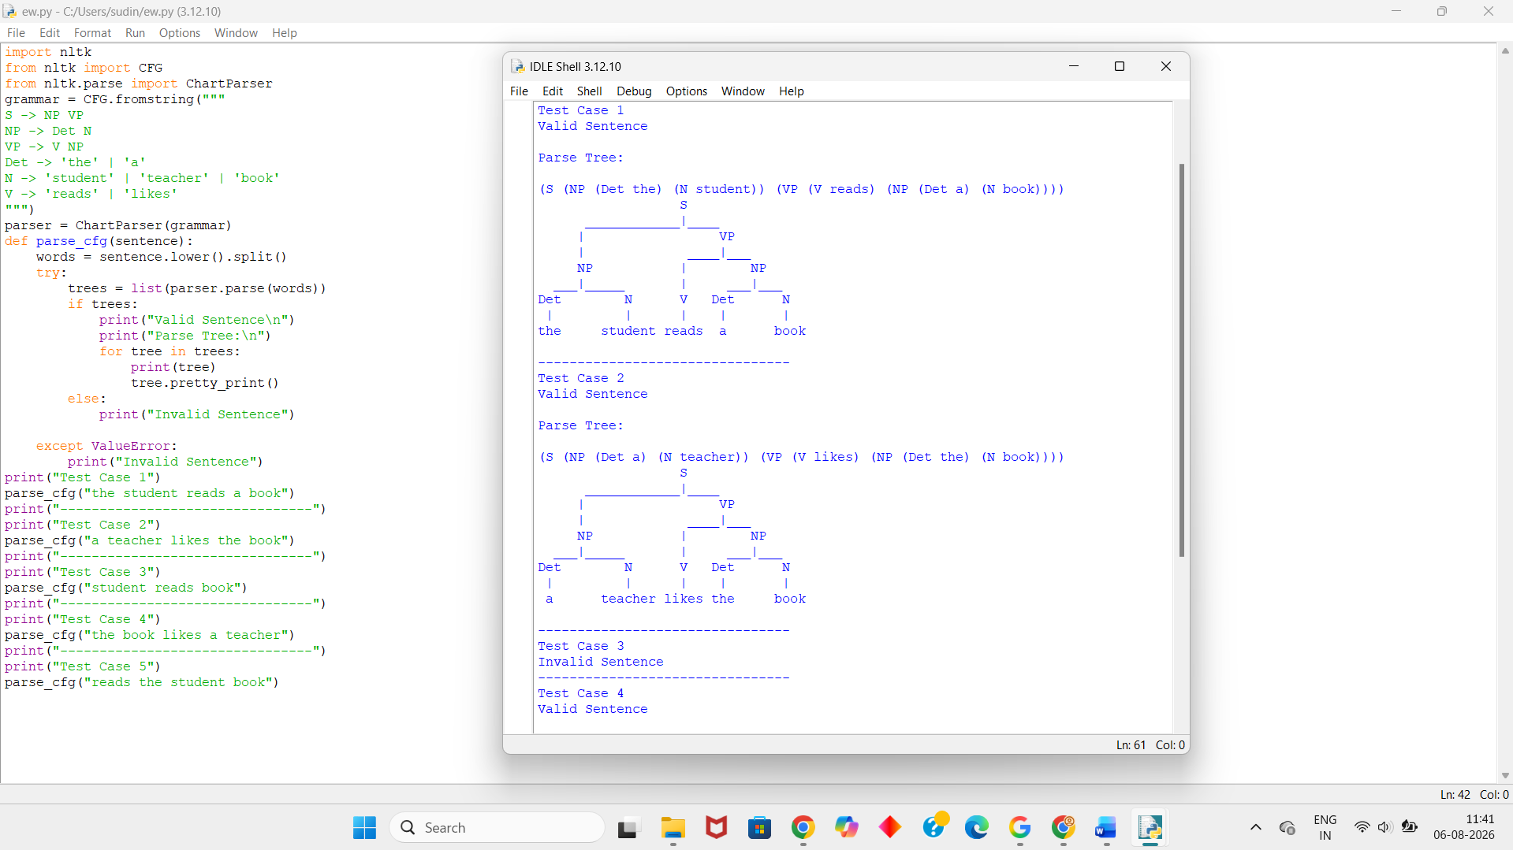
4. Analysis of Results:
Test Cases:
Test Case | Input Sentence | Expected Output | Actual Output | Status
1 | the student reads a book | Valid Parse Tree | Valid Parse Tree | Pass
2 | a teacher likes the book | Valid Parse Tree | Valid Parse Tree | Pass
3 | student reads book | Invalid Sentence | Invalid Sentence | Pass
4 | the book likes a teacher | Valid Parse Tree | Valid Parse Tree | Pass
5 | reads the student book | Invalid Sentence | Invalid Sentence | Pass
Result Analysis:
- The parser correctly validates sentences that satisfy the given CFG rules.
- Valid sentences produce parse tree representations.
- Invalid sentences are rejected because they do not follow the grammar.
- The parse tree clearly represents the grammatical structure of valid sentences.
5. Documentation:
Result:
The Python program successfully validates English sentences using the given Context-Free Grammar and generates parse tree representations for valid sentences. Invalid sentences are correctly identified and rejected.
Conclusion:
This experiment demonstrates the application of Context-Free Grammar in Natural Language Processing. The parser accurately checks sentence validity using grammar production rules and generates parse trees for valid sentences, helping to understand sentence structure and syntactic analysis.

EXP-2: Agreement and Feature Structure Checking
1. Understanding of Concepts:
Aim: To design a Python program that verifies subject–verb agreement using feature structures containing Number and Person attributes.
Objective
- To understand subject–verb agreement in Natural Language Processing (NLP).
- To represent grammatical information using feature structures.
- To compare the features of subjects and verbs.
- To determine whether a sentence is grammatically correct based on agreement rules.
Theory:
In Natural Language Processing (NLP), feature structures are used to represent grammatical information such as Number, Person, Gender, and Tense.
One important grammatical rule is subject–verb agreement, which states that the subject and the verb must agree in number and person.
Feature Rules:
Subject | Number | Person
he | Singular | Third
she | Singular | Third
it | Singular | Third
they | Plural | Third

Verb | Number
runs | Singular
writes | Singular
run | Plural
write | Plural
Agreement Rule:
A sentence is grammatically correct if:
- The subject and verb have the same Number.
- The subject and verb agree according to the defined feature structure.
Otherwise, the sentence is grammatically incorrect.
2. Experimental Design:
Algorithm:
Step 1: Create feature dictionaries for subjects and verbs.
Step 2: Accept the subject and verb as input.
Step 3: Check whether the subject and verb exist in the dictionaries.
Step 4: Compare the Number feature of the subject and verb.
Step 5: If both features match,
- Return True.
Step 6: Otherwise,
- Return False.
Step 7: Display the result.
Step 8: Stop.
Flowchart:
Start
│
▼
Create Subject & Verb Features
│
▼
Read Subject and Verb
│
▼
Compare Feature Structures
│
┌───────┴────────┐
│ │
▼ ▼
Features Match? No Match
│ │
▼ ▼
Print True Print False
│
▼
Stop
3. Use of Tools:
Tools Used:
- Google Colab
- Python 3
Python Program:
subjects = {
"he": ("singular", "third"),
"she": ("singular", "third"),
"it": ("singular", "third"),
"they": ("plural", "third")
}
verbs = {
"runs": "singular",
"writes": "singular",
"run": "plural",
"write": "plural"
}
def check_agreement(subject, verb):
subject = subject.lower()
verb = verb.lower()
if subject not in subjects or verb not in verbs:
return False
subject_number = subjects[subject][0]
verb_number = verbs[verb]
return subject_number == verb_number
print("Test Case 1")
print("Subject: he")
print("Verb: runs")
print("Output:", check_agreement("he", "runs"))
print("--------------------------------")
print("Test Case 2")
print("Subject: he")
print("Verb: run")
print("Output:", check_agreement("he", "run"))
print("--------------------------------")
print("Test Case 3")
print("Subject: they")
print("Verb: run")
print("Output:", check_agreement("they", "run"))
print("--------------------------------")
print("Test Case 4")
print("Subject: they")
print("Verb: writes")
print("Output:", check_agreement("they", "writes"))
print("--------------------------------")
print("Test Case 5")
print("Subject: she")
print("Verb: writes")
print("Output:", check_agreement("she", "writes"))
Output:
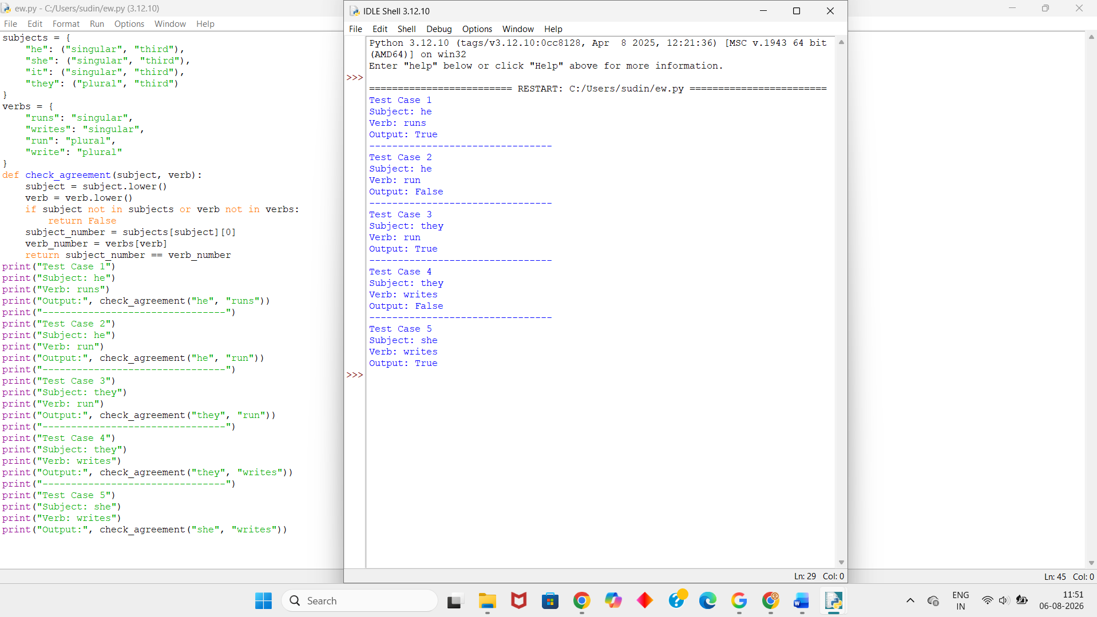
4. Analysis of Results:
Test Cases:
Test Case | Subject | Verb | Expected Output | Actual Output | Status
1 | he | runs | True | True | Pass
2 | he | run | False | False | Pass
3 | they | run | True | True | Pass
4 | they | writes | False | False | Pass
5 | she | writes | True | True | Pass
Result Analysis:
- The program correctly stores grammatical features for subjects and verbs.
- It successfully compares the Number feature between the subject and verb.
- If both features match, the program returns True.
- If the features do not match, the program returns False.
- All given test cases produce the expected results.
5. Documentation:
Result:
The Python program successfully verifies subject–verb agreement using feature structures. It correctly identifies whether the subject and verb agree in grammatical number and returns the appropriate Boolean result.
Conclusion:
This experiment demonstrates the use of feature structures for checking subject–verb agreement in Natural Language Processing. By comparing the grammatical features of the subject and verb, the program accurately determines whether a sentence satisfies the agreement rules. This technique is an important part of syntactic analysis and grammar checking in NLP systems.

EXP-3: Probabilistic Context-Free Grammar (PCFG) Parsing
1. Understanding of Concepts:
Aim: To design a Python program that parses a sentence using a Probabilistic Context-Free Grammar (PCFG) and computes its probability.
Objective:
- To understand the concept of Probabilistic Context-Free Grammar (PCFG).
- To compute the probability of a sentence using grammar production rules.
- To validate whether a sentence can be generated by the given PCFG.
- To return a probability of 0.00 if the sentence cannot be generated.
Theory:
A Probabilistic Context-Free Grammar (PCFG) is an extension of a Context-Free Grammar (CFG) in which every production rule is assigned a probability.
These probabilities indicate how likely a rule is to be used when generating a sentence.
The probability of a sentence is calculated by multiplying the probabilities of all production rules used to derive that sentence.
Grammar Used:
S → NP VP [1.0]

NP → John [0.6]

NP → Mary [0.4]

VP → runs [0.5]

VP → walks [0.5]
Probability Formula
P(Sentence) = P(S → NP VP) × P(NP) × P(VP)
Example:
For the sentence:
John runs
Probability:
P = 1.0 × 0.6 × 0.5
= 0.30
Similarly,
Mary walks
P = 1.0 × 0.4 × 0.5
= 0.20
If the sentence contains a word not present in the grammar (e.g., Peter), its probability is 0.00.
2. Experimental Design:
Algorithm:
Step 1: Define the probabilities for NP and VP.
Step 2: Accept a two-word sentence as input.
Step 3: Split the sentence into subject and verb.
Step 4: Check whether the subject exists in the grammar.
Step 5: Check whether the verb exists in the grammar.
Step 6: If both are present,
- Compute
Probability = P(S) × P(NP) × P(VP)
Step 7: Display the probability.
Step 8: Otherwise,
Display 0.00.
Step 9: Stop.
Flowchart:
Start
│
▼
Define PCFG Probabilities
│
▼
Read Input Sentence
│
▼
Split into Two Words
│
▼
Are Subject and Verb Valid?
│ │
Yes No
│ │
▼ ▼
Calculate Probability Print 0.00
│
▼
Display Probability
│
▼
Stop
3. Use of Tools:
Tools Used:
- Google Colab
- Python 3
Python Program:
NP = {
"John": 0.6,
"Mary": 0.4
}
VP = {
"runs": 0.5,
"walks": 0.5
}
S = 1.0
def sentence_probability(sentence):
words = sentence.split()
if len(words) != 2:
return 0.00
subject, verb = words
if subject in NP and verb in VP:
probability = S * NP[subject] * VP[verb]
return round(probability, 2)
else:

return 0.00
print("Test Case 1")
print("Input : John runs")
print("Probability :", sentence_probability("John runs"))
print("--------------------------------")
print("Test Case 2")
print("Input : John walks")
print("Probability :", sentence_probability("John walks"))
print("--------------------------------")
print("Test Case 3")
print("Input : Mary runs")
print("Probability :", sentence_probability("Mary runs"))
print("--------------------------------")
print("Test Case 4")
print("Input : Mary walks")
print("Probability :", sentence_probability("Mary walks"))
print("--------------------------------")
print("Test Case 5")
print("Input : Peter runs")
print("Probability :", sentence_probability("Peter runs"))
Output:
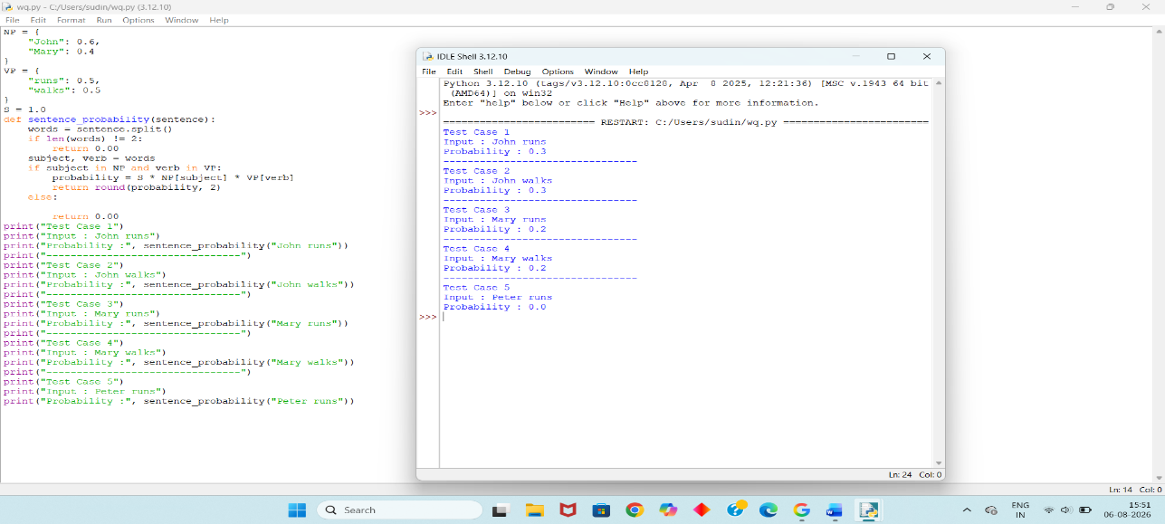

4. Analysis of Results:
Test Cases:
Test Case | Input Sentence | Expected Probability | Actual Probability | Status
1 | John runs | 0.30 | 0.30 | Pass
2 | John walks | 0.30 | 0.30 | Pass
3 | Mary runs | 0.20 | 0.20 | Pass
4 | Mary walks | 0.20 | 0.20 | Pass
5 | Peter runs | 0.00 | 0.00 | Pass
Result Analysis:
- The program correctly computes the probability of sentences using the given PCFG rules.
- It multiplies the probabilities of the grammar productions used to derive the sentence.
- Sentences that are part of the grammar produce the expected probabilities.
- Sentences containing unknown words return 0.00, indicating they cannot be generated by the grammar.
- All the provided test cases produce the expected results.
- Documentation:
Result:
The Python program successfully computes sentence probabilities using the given Probabilistic Context-Free Grammar (PCFG). It correctly identifies valid sentences, calculates their probabilities, and returns 0.00 for sentences that cannot be generated.
Conclusion:
This experiment demonstrates the application of Probabilistic Context-Free Grammar (PCFG) in Natural Language Processing. The program accurately parses valid sentences and computes their probabilities by multiplying the probabilities of the production rules. PCFGs are useful in NLP tasks such as syntactic parsing, speech recognition, and machine translation because they provide both grammatical structure and the likelihood of different sentence interpretations.

Rubrics for Calculation

Criteria | Weightage | Level 4 – Exemplary | Level 3 – Proficient | Level 2 – Developing | Level 1 – Beginning
Understanding of Concepts | 25 | Demonstrates thorough understanding and effectively integrates multiple concepts/technologies | Good understanding with proper integration of most concepts | Basic understanding; limited or partial integration | Poor understanding; unable to integrate concepts
Experimental Design | 30 | Well-planned, systematic implementation with optimal solution | Correct implementation with minor issues | Basic implementation with errors or inefficiencies | Incorrect or incomplete implementation
Use of Tools | 20 | Effective and advanced use of tools/technologies with proper configuration | Appropriate use of tools with correct execution | Limited or inconsistent use of tools | Incorrect or minimal use of tools
Analysis of Results | 15 | Insightful analysis with accurate interpretation and validation of results | Good analysis with reasonable interpretation | Basic analysis with limited insights | Poor or incorrect analysis of results
Documentation | 10 | Clear, well-structured documentation with diagrams, code, and results | Organized documentation with necessary details | Basic documentation with missing details | Poor or incomplete documentation

Q. No. / Criteria Level | Understanding of Concepts | Experimental Design | Use of Tools | Analysis of Results | Documentation | Sub. Total | Total %
1
2
3

Faculty In-charge | Course Coordinator | Program Director
Signature: _______________ | Signature: _______________ | Signature: _______________
Date: ___________________ | Date: ___________________ | Date: ___________________

